Oil Well Drilling
  - Labwork 1: IIA4117
This is a model of an oil well drilling with a single function of turning on or off the mud pump. A general drawing of such a rig can be seen in figure 1.
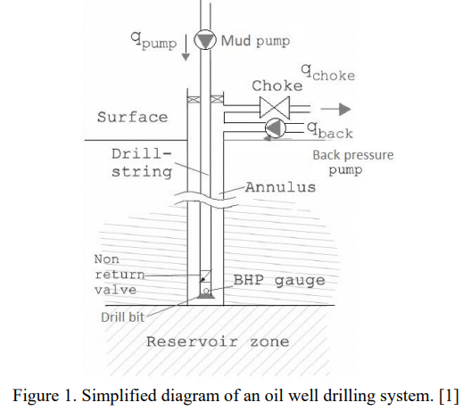
The model for the system can be seen in the equations below.
$$\frac{dP_{p}}{dt}=\frac{β_{d}}{A_{d}L}(q_{pump}- q_{bit})$$
$$\frac{dq_{bit}}{dt}=\begin{matrix}\frac{A_{d}}{ρ_{l}L}\left(P_{p}+ρ_{l}gL- {ΔP}_{f}^{d}-P_{bit}\right) & q_{bit}>0 \\ max⁡\left\{0, \frac{A_{d}}{ρ_{l}L}\left(P_{p}+ρ_{l}gL- {ΔP}_{f}^{d}-P_{bit}\right)\right\} & q_{bit}=0\end{matrix}$$
$$\frac{dP_{c}}{dt}=\frac{β_{a}}{A_{a}L}(q_{bit}+q_{res}+q_{back}-q_{choke})$$
$$\frac{dL}{dt}=v_{pen}$$
$$P_{bit}=P_{c}+ρ_{mix}gL+ΔP_{f}^{a}$$
$$ρ_{mix}=ρ_{w}W_{c}+\left(1-W_{c}\right)ρ_{l}$$
$$q_{res}=max\left\{0, PI(P_{res}-P_{bit})\right\}$$
$$q_{choke}= \frac{27.3}{3600 \sqrt{{10}^{5}}}Z_{c}(u_{c})\sqrt{\frac{max\left\{0, P_{c}-P_{0}\right\}}{ρ_{mix}}}$$
$$Z_{c}\left(u_{c}\right)= \left\{\begin{matrix}0 & u_{c}<5 \\ 0.111u_{c}-0.556 & 5≤ u_{c}<50 \\ 0.5u_{c}-20 & 50≤u_c\end{matrix}\right\}$$
$$\begin{matrix}ΔP_{f}^{x}=\frac{f_{d}Lρ_{x}v_{x}^{2}}{2D_{h}^{x}} & x = d ∨ a\end{matrix}$$
To simulate this, values from table 1 were used
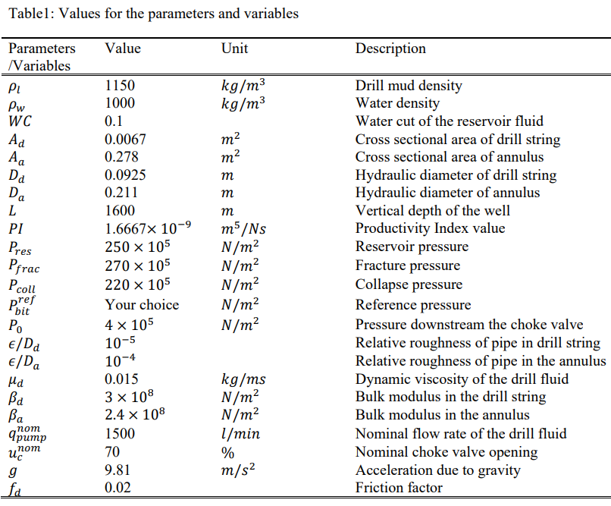

The following initial conditions were also used:
$$P_{p}=5⋅{10}^{6}[Pa]$$
$$q_{bit}=0.025[m^{3}/s ]$$
$$P_{c}=5.5⋅{10}^{6}[Pa]$$
$$q_{back}=0[m^{3}/s]$$
$${Δq}_{pump}=±300[l/\min^{2}]$$
The Simulink setup created can be seen in figure 2
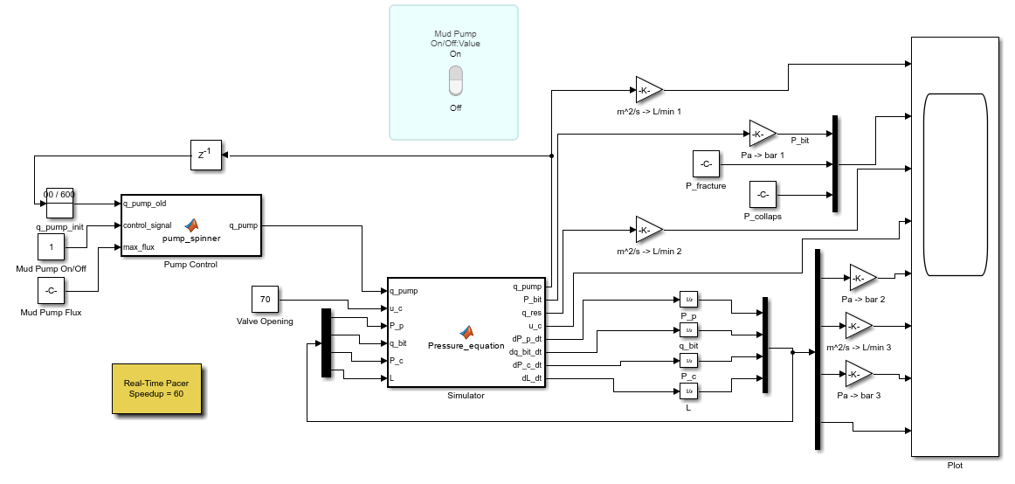
Figure 2: Simulink setup for modeling.
In figure 3 and figure 4, the pump_spinner and Pressure_equations MATLAB functions can be seen.
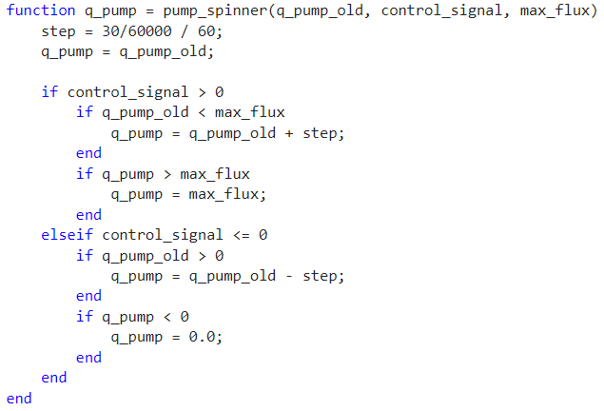
Figure 3: pump_spinner MATLAB function.
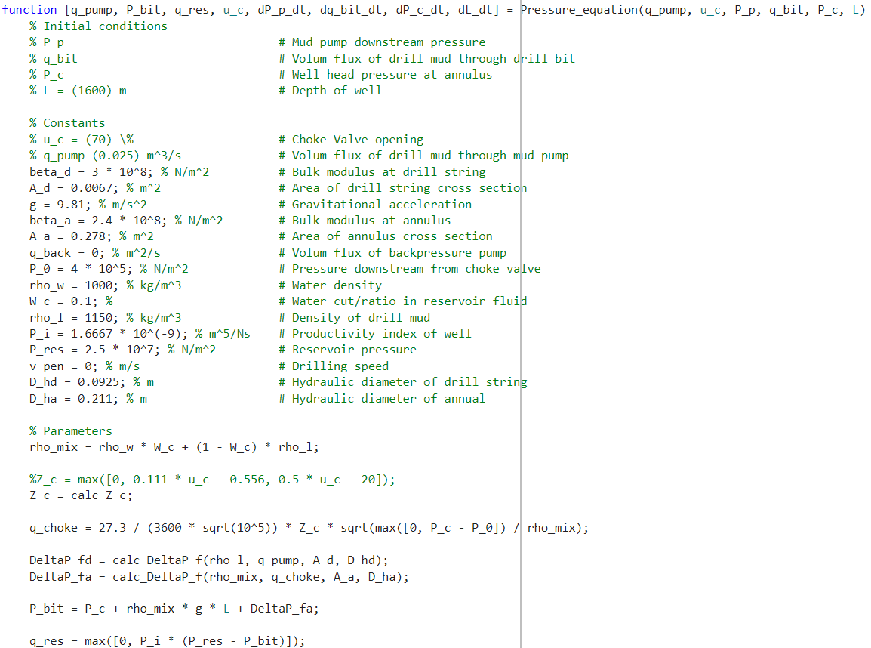
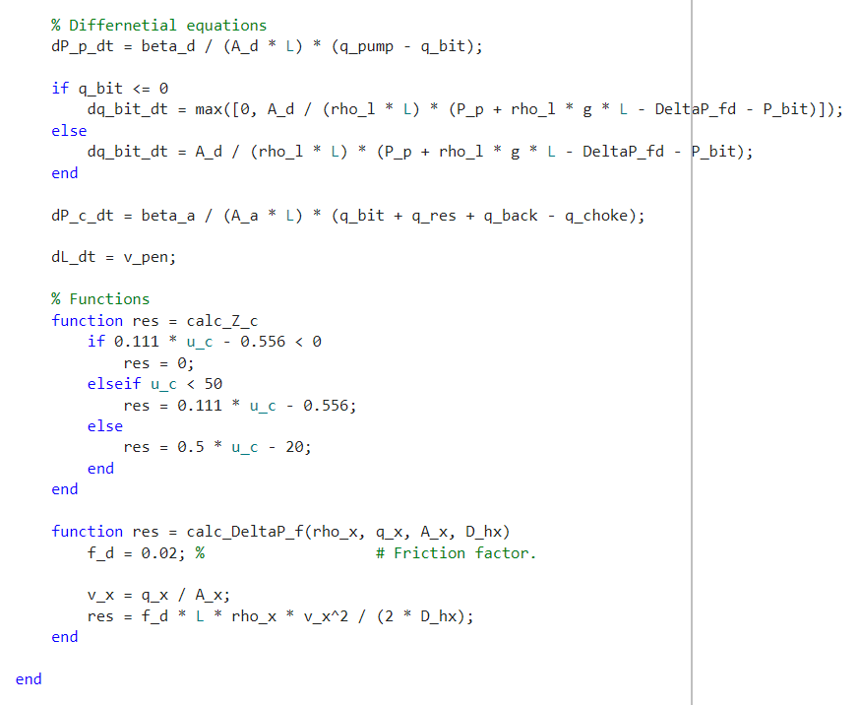
Figure 4: Pressure_equations MATLAB function.

Running this simulation, for 75 minutes, gives the plot seen in figure 5, where two breaks in the pumping of mud have been added manually via the button to control the mud pump.
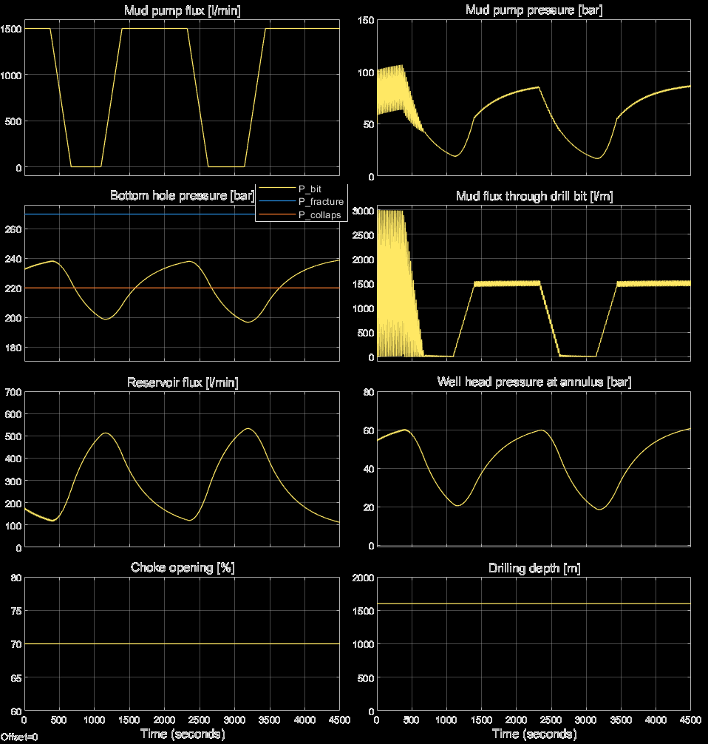
Figure 5: Results from running the simulation.
The results on the left-hand plots are basically the same as the once found in figure 3 of [1]. This is a sign that the simulation is done correctly. Another sign is that pressure sinks when the pump is turned off and rises when the pump is turned on. This follows naturally from the fact that more stuff pumped into the well means higher pressure and vice versa.
From the right-hand side plots in figure 5, mud pump pressure and mud flux through drill bit are quite unstable in the beginning. They are in fact very unstable until the mud pump is turned off once, then become much more stabile after that. If the mud pump is never turned off, they are unstable for the whole simulation. This is likely due to some instability with the initial condition, but it does however not seem to have any effect on the rest of the model. This is likely due to very high oscillation frequency.

Reference

[1] | R. Sharma, "Model Predictive Control," 25 August 2022. [Online]. Available: https://web01.usn.no/~roshans/mpc/downloads/oil-well-drilling-labwork1.pdf.

